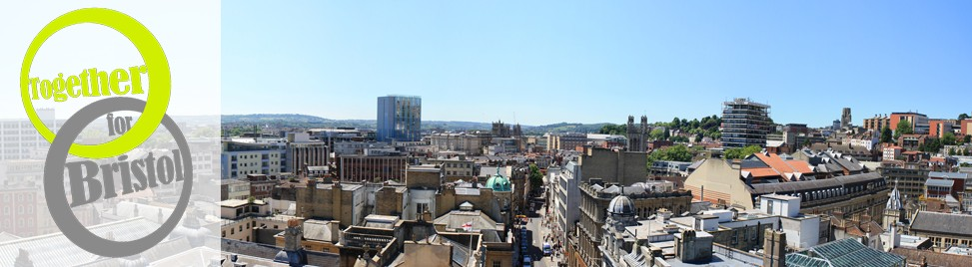

26th June 2013

Dear Church Leader,

TOGETHER FOR BRISTOL – A FESTIVAL OF LIFE

I am writing with an invitation to our event at the Colston Hall on Saturday 31st August.

You will know that Churches Together in Greater Bristol has joined with Arise! and the Evangelical Alliance under the banner “Together for Bristol” to produce an eclectic and exciting presentation showcasing how churches are working throughout the city for the benefit of their communities – celebrating all that we do. It all happens on Saturday 31st August at the Colston Hall. The theme for the event will be the eight spheres of life and will include exhibits, live performances, seminars and family activities, culminating in an evening of celebration. We’ve taken over the whole of the Colston Hall and are expecting many hundreds of people to come along and enjoy the day!

I am now inviting you, as a church leader, to a reception at St Stephen’s Church, City, on Saturday 31st August at 4.00 p.m. to meet with other leaders for tea. We will then walk to the Colston Hall in time to see the exhibits before the celebration event in the main hall at 6.00 p.m. That celebration promises to be spectacular, an extravaganza of worship and music, with choirs, bands, opera singers, dancers and much more. We very much hope that you will be able to join us. To help with numbers, please send your reply to vena@ccisr.org.uk

Even if you can’t come for the reception, please do drop in during the afternoon (we open at 12 noon) and catch a flavour of the work that your church is doing. The details are on the Bristol Networks website www.bristolnetworks.org.uk Going Deeper – Festival of Life

We look forward to seeing you.

Yours sincerely,

Jon Doble

Jon Doble
Acting Chairman


