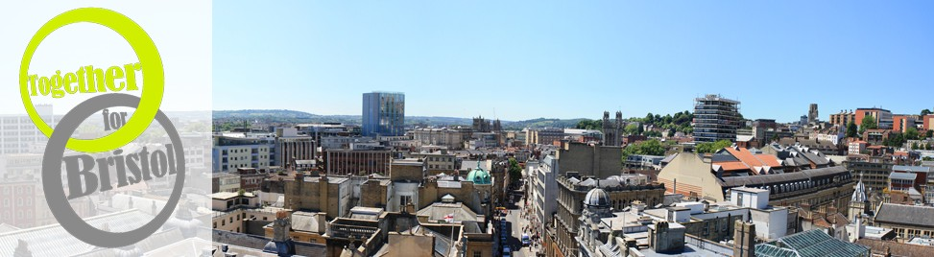
TOGETHER FOR BRISTOL EXHIBITORS

LOWER GROUND FLOOR (5)

Aspire
Blythswood Care
CCS Adoption
Crisis Centre Ministries
Global Aware - IF campaign including Christian Aid, Cafod, Tearfund and Fairtrade

GROUND FLOOR (9)

Bristol Area Quaker Meeting
International Christian Chamber of Commerce
Kingdom Creations
Prophetic Artists
Refresh Bedminster
South Bristol Child Contact Centre
St Mark’s Community Café
Together for Bristol including Churches Together in Greater Bristol, Bristol
Networks, the Evangelical Alliance and Arise!
UK Trade Centre

FIRST FLOOR (24)

5K Partnership
Ashley Churches Together Serving
Aslan Books
Association of Christian Counsellors
b.friend
Bristol Street Pastors
Broadmead Baptist Church
Carmel Bible College
Carmel Christian School
Changing Tunes
Cornerstone Church
Fingerprints in Uganda
Full Gospel Businessmen’s Fellowship in UK & Ireland
Gary Wilkinson Productions
Healing on the Streets, Bristol
ISR – Putting Faith to Work
Messy Church at St Christopher’s, Brislington
Open the Book
Pray for Schools
Premier Life
St Stephen’s City Church
The Methodist Church
The Pitch
The Salvation Army – Logos House
Cont. …

THIRD FLOOR (18)

Borderlands – The Assisi Centre
Bristol Baptist Bible College
Bristol Nightstop
Disabled Christians Fellowship – Premier Workshops
Global Aware - IF campaign including Christian Aid, Cafod, Tearfund and Fairtrade
Easton Jubilee Trust
Eden’s Tree Catering
Hebron Evangelical Church
Lee Abbey
LVC Music
Mahabba Bristol
New Generation Music
Parkwood Photography
The Salvation Army – anti-human trafficking
The Salvation Army – family services
Transform Work UK
Wildfire Church incl. Healing on the Streets, East Bristol
Youth With A Mission

